Hall 5, Booth L13 | Press Release  MTI Mischtechnik International GmbH  Katharina Nowak  Ohmstr. 8, D-32758 Detmold/Germany  Phone: +49 (5231) 914-113  Fax: +49 (5231) 914-299  Email: marketing@mti-mixer.de  Internet: http://www.mti-mixer.de
MTI at Solids 2020
Multi-talented lab mixers for trial mixtures and small-scale production
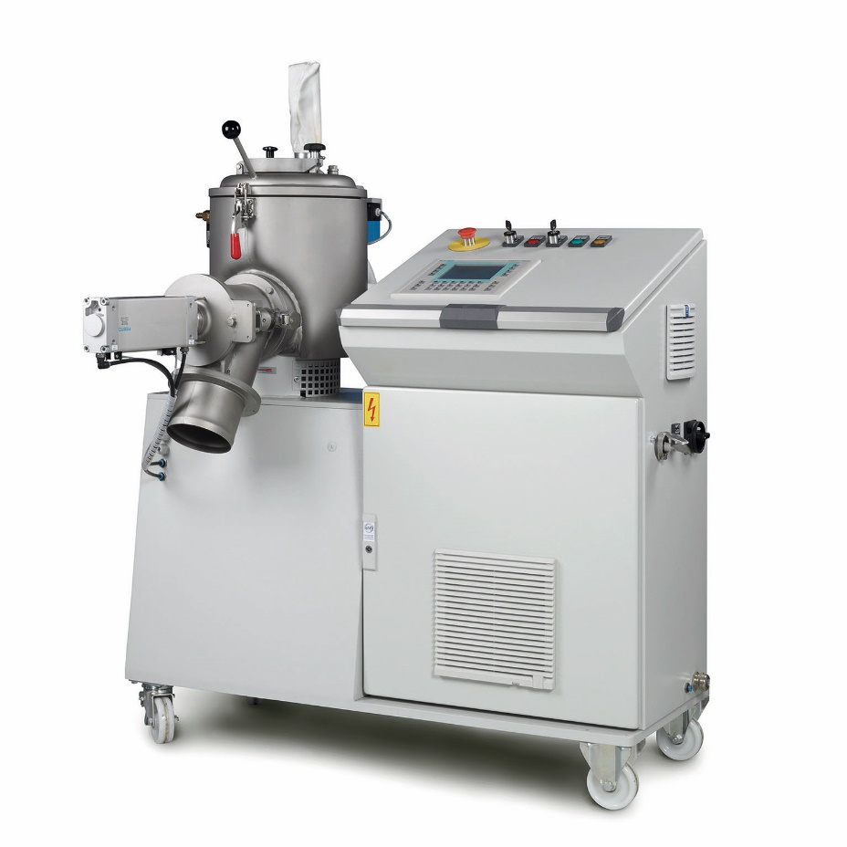
Solids 2020 will see MTI Mischtechnik showing its type M 10 laboratory mixer with its usable mixing vessel volume of up to 8 liters and optimisations for multipurpose use in the company's own R&D Center.
© MTI Mischtechnik
Detmold, Germany, February 2020 – At Solids 2020, which is set to take place on 24 and 25 June in Dortmund, MTI Mischtechnik will be focusing on its range of laboratory mixers with heatable and coolable mixing vessels. These all-rounders are suitable for the entire scope of bulk material processing tasks including the production of trial mixtures and small-scale production batches in laboratories and technology centers. Applications range from masterbatches and compounds for the plastics and rubber industry, including the production of natural fibre compounds, to applications in the chemical and automotive supplier industries.
MTI's laboratory mixer range includes the type M vertical high-speed mixers (working volume up to 28 liters), heating/cooling mixer combinations from the M/KMV series (working cooling mixer volume up to 51 liters) and the Uni tec type UT vertical universal mixers (working volume up to 51 liters). On a small scale, they cover the entire range of conventional industrial applications from homogenisation via friction mixing, coating, agglomeration and granulation to drying.
All MTI laboratory mixers share the same Plug-&-Play layout ensuring immediate usability and convenient handling together with easy cleaning enabling rapid formulation changes and very good emptying characteristics which maximise product yields. Various optional add-ons, such as liquid addition lances, choppers or the newly developed aspiration systems, expand the range of applications and enable reliable process design. MTI's R&D Center in Detmold gives its customers the opportunity to test laboratory mixers equipped in line with their requirements.
Whether the mixer is operated in manual or fully automatic mode, the included electronics acquire any desired measurement data which can be securely stored on local and cloud-based media and permit in-process and subsequent analysis, including on mobile devices. The ability to store numerous mixing programs means processes can be reliably and reproducibly repeated at any time.
As Ulrich Schär, General Manager at MTI, explains: "Our laboratory mixers are in use worldwide for trialing formulations and manufacturing small batches. Apart from our mixers' tried and trusted reliability, our customers particularly appreciate their versatility without the modifications often required for other systems and the ability to acquire all process and machine parameters for use in reliable process scale-up." Visitors to booth L13 in hall 5 will be able to see a type M 10 mixer optimised for multipurpose use in the company's own R&D Center.
MTI Mischtechnik International GmbH, established in 1975, is an internationally leading manufacturer of mixing and processing equipment for applications in the plastics processing industry including the production of natural fibre compounds, the chemical and the automotive industries. With a staff of over 60 working at its headquarters site in Detmold, Germany, the company manufactures mixer systems noted for their outstanding mixing performance as well as energy and cost efficiency. The portfolio includes vertical high-speed mixers, horizontal mixers, heating/cooling mixer combinations, universal mixers, laboratory mixers, as well as tailor-made systems. With exports accounting for around 80% of sales, MTI Mischtechnik is globally aligned and, as an owner-managed family business, relies on quality that is "Made in Germany".
Editorial contact / please send voucher copies to:
Dr.-Ing. Jörg Wolters, KONSENS Public Relations GmbH & Co. KG
Im Kühlen Grund 10, D-64823 Groß-Umstadt / Germany
Phone: +49 (6078) 9363-13, Fax: +49(6078) 9363-20
Email: mail@konsens.de, www.konsens.de
The text of this press release in MS-Word format, as well as the image in print-quality resolution, are available for download from:
http://www.konsens.de/mti-mischtechnik.html

